USMS Production Summary

Key USMS People:
- Donald Washington, USMS Director
- John Kilgallon, Chief of Staff to Director Donald Washington
- Derrick Driscoll, USMS Deputy Director
- Russel Burger, U.S. Marshal in Oregon
- Darrell White, USMS Judicial Security Division Assistant Director
- Jeffrey Tyler, USMS Associate Director
- Andrew Smith, USMS Tactical Operations Division Assistant Director
- Donald M. O’Keefe, U.S. Marshal in San Francisco
- Drew J. Wade, USMS Office of Public Affairs Chief
- Lisa Dickinson, USMS General Counsel
- Antoinette Bacon, Office of the Deputy Attorney General

Social Media Monitoring

Production Set 1 (pages 1-700):
  - August 15, 2020 correspondence from Burger to Washington, re “recent tweet re PDX protesting” (“There was some chatter in social media about setting one up a few days ago but nothing has happened.” (pg. 592))
  - July 26, 2020 Executive Summary of Demonstration Activities in Portland issued by the USMS Tactical Operations Division (noting that USMS deployed personnel to Portland, though the number of officers is redacted; mentioning that “[g]roups are forming to protest the federal presence” such as “wall of moms” and “wall of vets” and that “it is unclear how many plan to attend Saturday, but over a thousand are following”) (pg. 399))
    - (Note: The reference to “following” may indicate that USMS was monitoring protest groups’ social media)
  - July 25, 2020 correspondence from White to Driscoll and Kilgallon re “JSD [Judicial Security Division]/OPI [Office of Protective Intelligence Report” (noting that other “prominent leftist groups in Portland, such as PDX Resistance and Popular Mobilization, or PopMob for short, have shared PNW Youth Liberation Front’s posts and actions on social media . . . . However, there is no indication these groups are organizing together in any capacity. (pg. 424))
  - July 23, 2020 correspondence from [redacted] of the Portland Police Bureau to Burger, re “Portland City Council Resolution” (commenting on Portland City Council’s passage of a resolution that restricts the Portland police department from receiving operational support from federal agents, and noting the resolution “includes but is not limited to embedding in a federal incident command center, sharing or receiving information from above defined federal forces, engaging in policing or crowd control measures with above federal forces” (pg. 547))
  - July 6, 2020 correspondence from Burger to Driscoll re “Operations Update” (noting that the FBI has “had a task force up for 3 weeks reviewing video to identify suspects” (pg. 488); noting that “A Federal judge granted a restraining order that prohibits the use of gas except under certain circumstances (life danger) further tying the hands of the police who are exhausted from having to deal with non-stop assaults for the last month.” (pg. 490))
  - July 3, 2020 correspondence from [redacted] of the USMS Pacific N.W. Violent Offender Task Force, to Burger re “Demonstration and Criminal Activity Outside the Justice Center and Federal Courthouse July 2, 2020” (describing a demonstration that occurred on July 2 outside the federal courthouse; including a link to a tweet with video content: https://twitter.com/mrandyngo/status/1278962503121133570?s=21 (pg. 283))
  - June 15, 2020 correspondence from Tyler to Washington and USMS personnel re “Portland OR/Seattle WA Judicial Security Situation Report” (describing June 15 protests in Portland and Seattle; noting that in Seattle there was a “small group (few hundred) want[ing] to take over the West Precinct” and that “[t]here was a Facebook stream from the quasi-leader, leading this effort.” (pg. 560))

Production Set 2 (pages 701-1400):
  - September 25, 2020 Executive Daily Summary regarding demonstrations Portland issued by the USMS Tactical Operations Division (emailed daily to USMS leadership) (“unconfirmed intelligence suggests that 2700 protestors from Chicago are coming in this weekend [to Louisville]” (pg. 248))
  - Daily Correspondence re “D/OR Portland Courthouse Activity Summary” (emailed daily from Burger to USMS leadership):
    - August 25, 2020: Describing an arrest of two subjects “who were flying a drone” that was operating within a temporary flight restriction zone; the subjects permitted the FPS investigators to review their video footage (pg. 468)
    - August 22, 2020: Including images from Facebook (see Facebook insignia in below thumbnails) that were being streamed or posted from Portland (pg. 506); also including images from “WokeNet” which compiles live streams or uploaded videos from protesters’ phones (pg. 509)

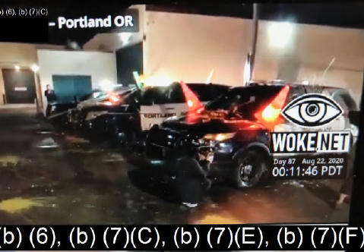

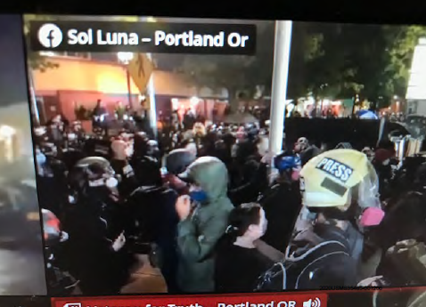

    - Frequent mentions of live streams occurring during protests:
      - October 25, 2020: “Multiple live streams in Portland. They appear to be located outside the ICE facility.” (pg. 112)
      - October 12, 2020: “No ‘live stream’ available.” (pg. 162)
      - October 8, 2020: “No live stream available, all quiet.” (pg. 178)
      - August 15, 2020: “Many of the VO [violent opportunists] are hiding behind individuals wearing “Press” markings which is making it difficult to arrest/clear the crowd. Protesters are heard on live stream telling the group to go back to SE Precinct.” (pg. 572)

Production Set 3 (pages 1401-1700):
  - July 18, 2020 daily correspondence from Burger to USMS leadership re “Portland courthouse” (including another screenshot from Woke Net (pg. 172))

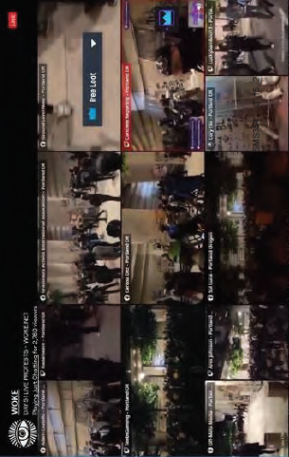

  - July 17, 2020 daily correspondence from Burger to USMS leadership re Portland courthouse (noting that “PPB [Portland Police Bureau] as well as live stream reports lasers being used to interfere with cameras” (pg. 184))

Deputization & Other Topics of Interest

Production Set 1 (pages 1-700):
  - June 3, 2020 correspondence from Burger to [redacted], copying Driscoll, Tyler and Dickinson, re “Request to Use Non-FPS DHS LEO to protect USCH” (“I know the US Border Patrol was an integral part of the law enforcement response in Los Angeles during the LA Riots.” (pg. 606); “Per the message below, FPS is requesting that we deputize US Border Patrol and ICE agents to assist us and FPS in protecting courthouses. Thought we better run this one up the flag pole to see if there are any issues with doing so.” (pg. 606))
- June 5, 2020 correspondence from Driscoll to Bacon, copying Kilgallon and Tyler, with attachment titled “Special Deputations Documents June 5, 2020” (redacted per (b)(5) (pg. 20))
- June 5, 2020 Executive Summary regarding demonstrations issued by the USMS Tactical Operations Division (explaining the Special Deputations Program, including who can approve exemptions to the Special Deputations Program and noting that most military personnel are precluded from being deputized; “The Posse Comitatus Act precludes most military personnel from being deputized. However, United States Coast Guard and National Guard service members are exempt from this restriction.” (pg. 22); describing requirements for deputization, such as “1 year of law enforcement experience with an agency that has general arrest authority” and “have no domestic violence convictions” but also redacting the “justifications” section regarding these requirements (pg. 24))
- July 21, 2020 correspondence from Discroll to Tyler and Kilgallon re “JSD - Portland Intelligence” (sharing information provided by OPI [Office of Protective Intelligence within USMS] regarding “similar situations in the past and how the groups were dealt with”; describing “like groups” such as the Occupy movement, Black Bloc, and Red Army Faction (pg. 408-411))
- July 24, 2020 correspondence from O’Keefe to Tyler, White, Kilgallon, and Wade re “Upcoming Protest in Oakland” (“Due to the sensitivity of current events and concerns from our state and local partners, and the talk about federal agents going into cities, including Oakland, all personnel will not be wearing “military type” clothing.” (pg. 648))
- August 26, 2020 correspondence from Driscoll to Tyler and Smith re “Proposed Portland Force Realignment 8-26-20” (updating colleagues on USMS involvement in Wisconsin, “I told the USA we’re not trained/equipped to do crowd control but can arrest and support other LE arrests of all violent opportunist . . . additionally, [redacted (b)(7)(E)] can perform [redacted (b)(7)(E)] . . . he was very happy to hear that.” (pg. 569)).

Production Set 2 (pages 701-1400):
  - Executive Daily Summaries regarding demonstrations in Portland issued by the USMS Tactical Operations Division (sent daily to USMS leadership):
  - Nov. 9, 2020: “JOC [FBI Joint Operations Center] has been activated to monitor potential civil unrest as a result of the 2020 Presidential Election.” (pg. 2)

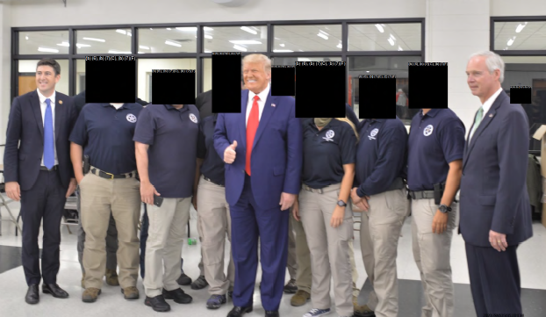

  - August 25, 2020: “PPB [Portland Police Bureau] reported that the ‘Press’ was throwing rocks at them throughout the night.” (pg. 465)
  - Daily Correspondence re “D/OR Portland Courthouse Activity Summary night of . . .” (sent daily from Burger to USMS leadership):
    - September 28, 2020: “We deputized about [redacted] Portland PD Officers and [redacted] Multnomah County Deputy Sheriff’s [sic] on Saturday. Their Special Deputations are good until 12/31/20.” (pg. 229)
    - September 20, 2020: In anticipation of the decision in the Taylor case, “I’ve approved the deployment of [redacted] TDY [temporary duty] deputies to the area to support anticipated USMS operations.” (pg. 278)
- October 28, 2020 correspondence from [redacted] to US Marshals and USMS Chiefs email distribution lists re “Potential for Threats Against USMS Protective Interests Surrounding the 2020 Presidential Election 010 28 2020” (redacted per (b)(5), (b)(7)(E) (pg. 96-103))

